5th December 2013

**WTCC YOKOHAMA Independent Trophy Champion joins YOKOHAMA at Autosport Awards**

The 2013 FIA World Touring Car Championship YOKOHAMA Independents' Trophy winner, James Nash, joined staff from Yokohama HPT Ltd., YOKOHAMA´s UK based distributor, at this year's prestigious Autosport Awards ceremony in London. Nash, who also finished third in the overall championship at the wheel of his YOKOHAMA control tyre-shod Bamboo Engineering Chevrolet Cruze, was delighted to join YOKOHAMA at the event, which was attended by drivers and VIPs from across the world of motorsports.

The event celebrated its 25th anniversary this year and was attended by 2014 Formula One champion Sebastian Vettel, FIA World Rally Champion Sebastien Ogier and a host of personalities from the world of motorsport, including John Surtees, Niki Lauda, Emmerson Fittipaldi and Sir Sterling Moss.

Numerous awards were given by the publishers of Autosport Magazine and the culmination of the evening was the McLaren Autosport BRDC award to an up and coming driver. Previous winners include Dario Franchitti and Jenson Button and the selection process is based on numerous criteria, as well as performance at the wheel of a host of vehicles, including a DTM car, a GT racer and a YOKOHAMA-shod single-seater.

Three of the six short-listed drivers came from the 2013 BRDC Formula 4 series, which was new for this year and used YOKOHAMA control dry slick and wet weather tyres. It generated full grids and exceptional racing, with an eight-race Winter Series also run to provide additional seat time for racers and team.

Commenting, Head of Motorsport at Yokohama HPT Ltd, Mark Evans, said; "It was a pleasure to have James join us at the Autosport Awards. It really is one of the highlights of the motorsport season and it was fantastic to be able to congratulate James for his achievement at such a prestigious event.

"It was also very good to see three drivers from this year's F4 championship nominated for the young drivers´ award. I think it goes to show what a valuable series F4 is for up and coming drivers and we are delighted to be involved with the series."

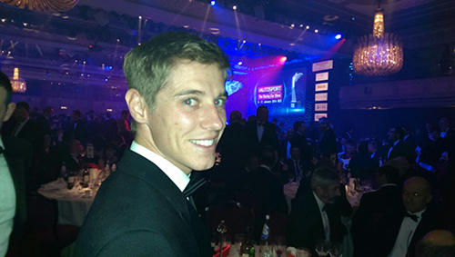

WTCC YOKOHAMA Independent Trophy champion James Nash at the 2013 Autosport Awards with YOKOHAMA